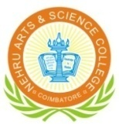
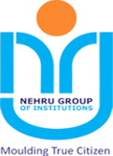

NEHRU ARTS AND SCIENCE COLLEGE
(An Autonomous Institution affiliated to Bharathiar University)
(Reaccredited with “A” Grade by NAAC, ISO 9001:2015& 14001:2004 Certified
Recognized by UGC with 2(f) &12(B), Under Star College Scheme by DBT, Govt. of India)
Nehru Gardens, Thirumalayampalayam, Coimbatore - 641 105, Tamil Nadu.

Annual Performance Rating of the Head of the Department – (2023 – 24)
(To be filled by the Members of Faculty)

1. Department : ______________________________
2. Name of the HoD : _______________________________ Total : 110 marks

RATING BASED ON THE FOLLOWING CRITERIA Out of 100 Marks
(Excellent – 5, Very Good – 4, Good – 3, Average – 2, Below Average – 1)

(Each Criterion carries Maximum of 5 Marks)
S. No | Criteria | Marks
 | Effective Communication
 | Respects Others
 | Teamwork
 | Time Management
 | Allocation of Work
 | Interpersonal Relationships
 | Trust and Integrity
 | Unbiased
 | Professionalism
 | Manages Conflict
 | Decision-making
 | Promotes Learning
 | Flexibility and Ability to multi-task
 | Follow-up
 | Taking action when a situation or problem arises
 | Willing to support the ideas of others
 | Instinctively helps others without being asked
 | Journal publication
 | Book an Book Chapter
 | Overall Performance
Total

Out of 10 Marks

Rating by Principal

Total:

